Continuous Bag of Words (CBOW):
Efficient Context-Based Learning of Word Embeddings
in the Word2Vec Framework
A Comprehensive Academic Research Paper
Topics: NLP · Word Embeddings · Neural Language Models · Distributional Semantics
April 2026

Abstract
The Continuous Bag of Words (CBOW) model is one of the two core architectures in the Word2Vec framework, introduced by Mikolov et al. (2013). By predicting a target (center) word from its surrounding context words, CBOW learns dense low-dimensional vector representations of words — known as word embeddings — in an efficient, self-supervised manner. This paper provides a comprehensive explanation of CBOW's intuition, mathematical formulation, neural network architecture, training process, optimization techniques (Negative Sampling, Hierarchical Softmax), advantages, limitations, and comparison with Skip-gram. We also discuss CBOW's role as the foundational stepping stone toward modern contextual models such as GloVe, FastText, and BERT.

1. Introduction
Natural Language Processing (NLP) requires machines to understand the meaning of words. Traditional representations suffered from fundamental limitations:
- One-Hot Encoding: Vectors of size V (vocabulary size) with a single 1. High dimensionality, no semantic similarity between words — "king" and "queen" are equally distant as "king" and "table".
- Bag of Words (BoW): Ignores word order and captures no relational meaning between words.
- TF-IDF: Captures word importance in documents but not semantic relationships between words.
These limitations motivated neural word embedding models. Word2Vec (Mikolov et al., 2013) introduced two architectures — CBOW and Skip-gram — that learn dense, low-dimensional vector representations where semantically similar words are close in vector space [1].
Thesis: CBOW is a fast and simple method for learning distributed word representations. It is not just a model — it is a foundational idea that shaped all modern NLP: the distributional hypothesis operationalized as a neural prediction task.

2. Background

2.1 The Distributional Hypothesis
"You shall know a word by the company it keeps." — J.R. Firth (1957). This is the core principle behind all word embedding models: words that appear in similar contexts tend to have similar meanings. CBOW operationalizes this by learning to predict a word from its context [2].

2.2 Word2Vec Framework
Word2Vec (Mikolov et al., 2013) is a framework for learning word embeddings from raw text through self-supervised learning — no human annotation required. It contains two architectures:
- CBOW (Continuous Bag of Words): Predict the center word from context words (this paper)
- Skip-gram: Predict context words from the center word
Both learn a word embedding matrix W (V×d) where d is the embedding dimension (typically 100–300). The rows of W become the learned word vectors.

3. Core Idea of CBOW

3.1 Objective
Objective: Given the surrounding context words within a sliding window, predict the target (center) word. CBOW treats all context words equally — it is a "bag" because order is ignored, and the context vectors are simply averaged.

3.2 Worked Example
Example: Sentence: "The quick brown fox jumps over the lazy dog." | Center word: "fox" | Context (window=2): ["quick", "brown", "jumps", "over"] | Task: Predict "fox" from the average of the 4 context word vectors.

3.3 Sliding Window Visualization
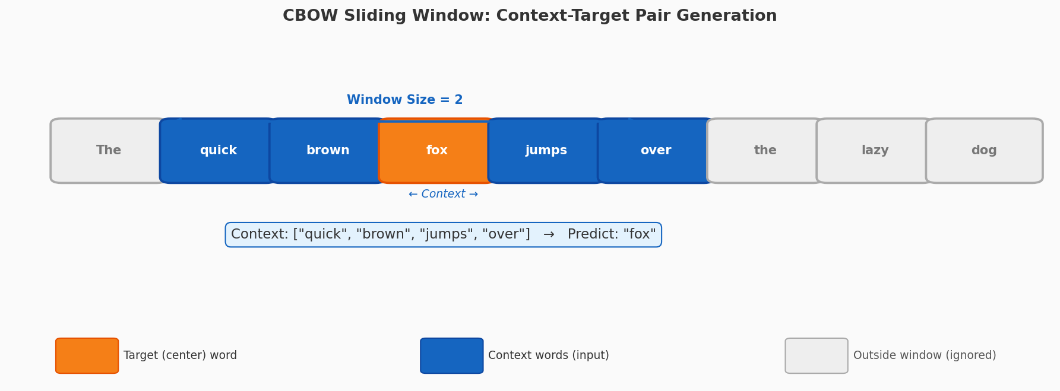
Figure 1: CBOW sliding window mechanism. Orange = target word to predict. Blue = context words (input). Gray = words outside the window (ignored for this step).
Window size controls the trade-off: larger windows capture broader topical context; smaller windows capture tighter syntactic relationships. Typical values: 2–5.

4. Mathematical Formulation

4.1 Context Vector Averaging
Given context words w₁, w₂, ..., w_{2m} (window size m on each side), their embeddings are looked up and averaged:

Context Average | v̂ = (1/2m) Σᵢ vᵢ where vᵢ = embedding of context word i

4.2 Softmax Probability
The probability of the target word w_O given the averaged context vector v̂:

Softmax P(w_O|ctx) | P(wO|context) = exp(v'ᵀwO · v̂) / Σᵥ exp(v'ᵀw · v̂)

Where v'_w is the output embedding of word w (the second embedding matrix W'). There are two embedding matrices: W (input embeddings) and W' (output embeddings).

4.3 Objective Function (Log-Likelihood)
The training objective is to maximize the average log-likelihood over all T training words:

Objective J(θ) | J(θ) = (1/T) Σt log P(wt | context(wt))

Equivalently, we minimize the negative log-likelihood (cross-entropy loss). Backpropagation computes gradients with respect to both W and W', which are updated via gradient descent.

5. Neural Network Architecture
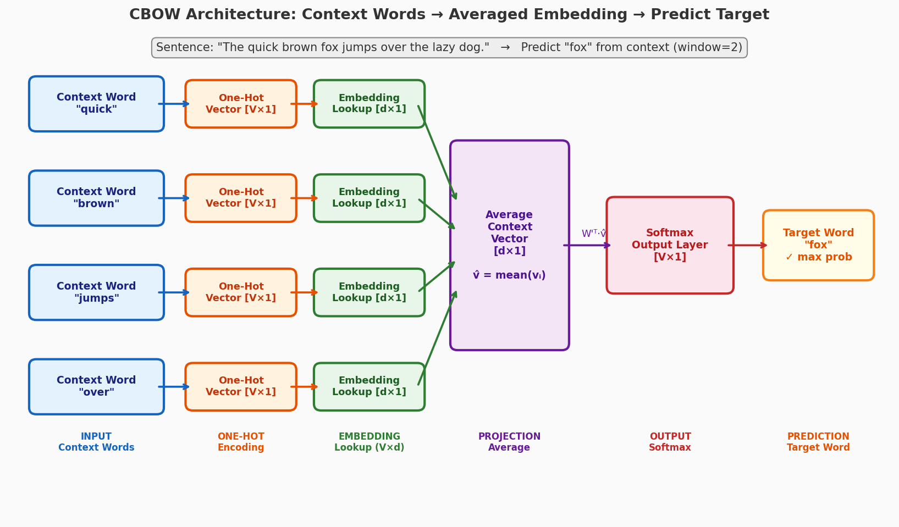
Figure 2: Full CBOW architecture. Context words are one-hot encoded, looked up in the embedding matrix, averaged into a single context vector v̂, then multiplied by the output matrix and passed through Softmax to predict the target word.

5.1 Layer-by-Layer Breakdown
- Input Layer: One-hot vectors of 2m context words, each of size V (vocabulary size).
- Embedding (Projection) Layer: Shared lookup table W (V×d). Each one-hot vector selects a row → d-dimensional embedding. No activation function — purely linear lookup.
- Averaging Step: The 2m embedding vectors are averaged into a single d-dimensional context vector v̂. This is the "Bag" in CBOW — order is discarded.
- Output Layer: v̂ is multiplied by W' (d×V) and passed through Softmax to produce a probability distribution over all V words.
- Learned Embeddings: After training, the rows of W (input embedding matrix) are the final word vectors used downstream.

6. Training Process

6.1 Data Generation
For each word at position t in the corpus, a training pair (context, target) is generated:
- Slide a window of size 2m+1 over the entire corpus
- The center word is the target (label)
- The 2m surrounding words are the input context
- For a corpus of T words: generate approximately T × 2m training pairs

6.2 Forward Pass
- Step 1 — Embedding lookup: retrieve the d-dimensional vector for each context word from W
- Step 2 — Average: compute v̂ = mean of all context embeddings
- Step 3 — Output scores: compute u = W'ᵀ · v̂ (V-dimensional score vector)
- Step 4 — Softmax: convert scores to probabilities P(w|context) for all V words

6.3 Loss & Backpropagation
Loss: Cross-entropy loss L = −log P(w_target | context). Backpropagation computes ∂L/∂W and ∂L/∂W'. Gradient descent updates both embedding matrices.
Computational bottleneck: The Softmax denominator requires summing over all V words (often 50,000–1,000,000). This makes each update O(V), which is impractical — motivating the optimization techniques below.

7. Optimization Techniques

Technique | Complexity | How It Works | Trade-off
Full Softmax | O(V) | Normalize over all vocabulary words | Exact but very slow for large V
Hierarchical Softmax | O(log V) | Binary Huffman tree; traverse to word | Fast; Huffman favors frequent words
Negative Sampling | O(k) k≈5–20 | Binary classification: real vs noise samples | Very fast; slight quality trade-off

Table 1: Comparison of softmax optimization techniques for CBOW training

7.1 Negative Sampling
Instead of computing full softmax over all V words, Negative Sampling frames training as binary classification: given (context, word) pair, is it a real pair (from data) or a noise pair (random word)?
Neg. Sampling Loss | L = log σ(v'ᵀwO · v̂) + Σk log σ(−v'ᵀwk · v̂)

Where k = 5–20 negative samples per positive example. Negative words are sampled proportionally to f(w)^0.75 — a smoothed unigram distribution that increases sampling of rare words. This reduces complexity from O(V) to O(k) per update [1].

7.2 Hierarchical Softmax
Arranges the vocabulary in a binary Huffman tree where each word is a leaf. Traversal from root to leaf defines the word's probability as a product of binary decisions. Complexity: O(log V). Frequent words get shorter paths (Huffman property), so common words are found faster.
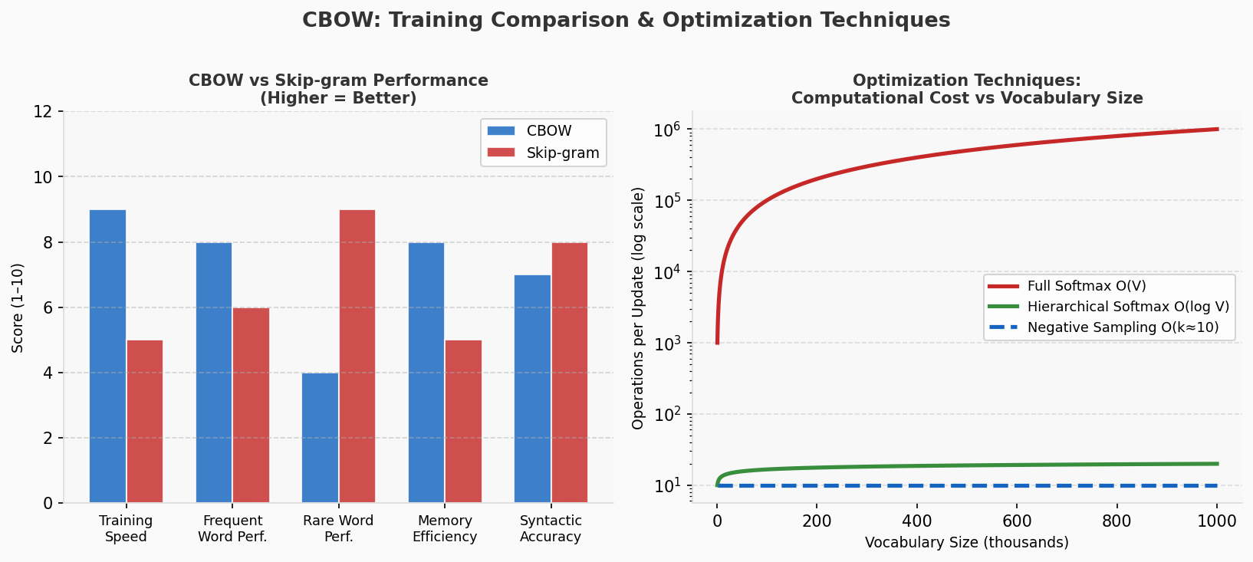
Figure 3: Left — CBOW vs Skip-gram performance comparison across 5 dimensions. Right — Computational cost of each optimization technique as vocabulary grows (log scale).

8. Word Embedding Space
After training, the embedding matrix W encodes rich semantic and syntactic information:
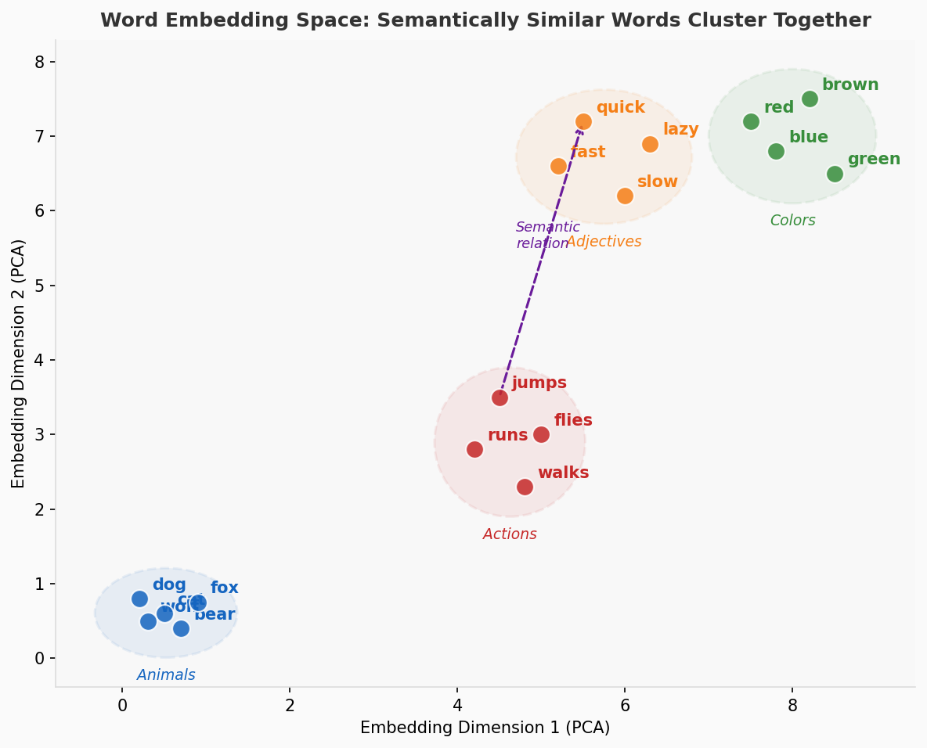
Figure 4: 2D PCA projection of CBOW word embeddings. Semantically similar words cluster together: Animals (blue), Actions (red), Colors (green), Adjectives (orange).

Key properties of learned embeddings:
- Semantic clustering: "dog", "cat", "fox" are close; "jumps", "runs" are close
- Syntactic relationships: Plural/singular, verb tenses captured as consistent vector offsets
- Analogical reasoning: vec("king") − vec("man") + vec("woman") ≈ vec("queen")
- Dimensionality: Typical d=100–300 vs V=50,000+. Enormous compression with meaningful geometry

9. Advantages of CBOW
- Training speed: Significantly faster than Skip-gram because one prediction per center word (not 2m predictions). Suitable for very large corpora (billions of words).
- Frequent word performance: Context averaging smooths out noise and produces stable representations for common words and syntactic patterns.
- Memory efficiency: One embedding matrix W plus output W'. Lower GPU/RAM footprint than Skip-gram.
- Noise robustness: Averaging over multiple context words acts as a form of regularization — individual noisy context signals are dampened.
- Simplicity: Easy to implement, tune, and understand. The architecture is a two-layer network with no activation in the hidden layer.

10. Limitations of CBOW
- Rare word representations: Infrequent words appear in fewer training pairs → their embeddings are trained on less data → weaker, less reliable representations. Skip-gram handles rare words better.
- Loss of word order: Averaging context vectors destroys positional information. "The dog bit the man" and "The man bit the dog" produce the same context vector if word content is identical.
- Context signal dilution: Important context words can be "averaged out" by less informative surrounding words. Skip-gram treats each context word separately.
- Static embeddings: One fixed vector per word regardless of context — cannot handle polysemy. "bank" (river) and "bank" (financial) share one vector. BERT's contextual embeddings solve this.
- Linear relationships only: The embedding space captures linear analogies well but misses higher-order semantic relationships.

11. Comparison with Skip-gram
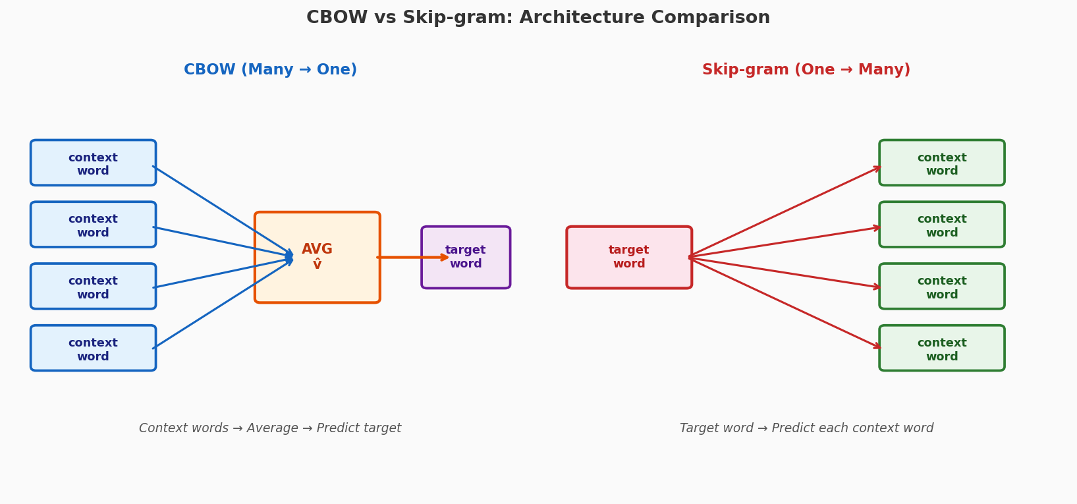
Figure 5: Architecture comparison. CBOW (left): multiple context words → average → predict one target. Skip-gram (right): one target word → predict each context word independently.

Aspect | CBOW | Skip-gram
Objective | Predict target from context words | Predict context words from target
Direction | Many-to-one (context → target) | One-to-many (target → context)
Training Speed | Faster (fewer updates per word) | Slower (more training pairs)
Frequent Words | Better performance | Slightly worse
Rare Words | Weaker representations | Stronger representations
Semantic Analogies | Good | Excellent
Syntactic Patterns | Very good | Good
Memory Usage | Lower | Higher
Best Use Case | Large corpora, frequent vocab | Small corpora, rare words important

Table 2: Detailed comparison of CBOW vs Skip-gram across all key dimensions

Practical Guideline: Use CBOW when: training on large corpora and speed matters; frequent word quality is the priority. Use Skip-gram when: data is small; rare word quality matters; you need the best semantic analogy performance.

12. Applications
- Text Classification: Average word embeddings as document features for sentiment analysis, topic detection, spam filtering
- Information Retrieval: Semantic search — find documents similar in meaning not just keyword overlap
- Named Entity Recognition: Embeddings as features improve entity detection (person, location, organization)
- Machine Translation: Embeddings as encoder inputs; bilingual embeddings bridge language gaps
- Transfer Learning: CBOW embeddings as pretrained initialization for downstream neural models — dramatically reduces labeled data needed
- Recommendation Systems: Item2Vec applies CBOW-style training to user-item sequences for product recommendation

13. Modern Context and Evolution

13.1 Improvements Over CBOW
- GloVe (2014): Combines CBOW-style local context windows with global co-occurrence statistics. Trains on a full co-occurrence matrix rather than sliding windows.
- FastText (2016): Extends CBOW with subword (character n-gram) information. Handles rare words and morphologically rich languages (Arabic, Turkish, German) far better.
- ELMo (2018): Deep bidirectional LSTM produces context-dependent embeddings — same word gets different vectors in different sentences.
- BERT (2018): Transformer-based model with Masked Language Modeling (a CBOW-like objective) but with full bidirectional context and attention mechanisms. Solves polysemy completely.
- GPT series (2018–2024): Autoregressive language models that predict the next word (Skip-gram-like directional prediction) at massive scale.

13.2 Why CBOW Remains Important
Despite being surpassed by contextual models, CBOW remains conceptually foundational:
- It introduced the idea of self-supervised learning from raw text — no labels needed
- The Masked Language Modeling objective in BERT is a direct descendant of CBOW
- For resource-constrained applications, CBOW embeddings are still fast and effective
- The distributional hypothesis it embodies remains the core principle of all modern NLP

14. Conclusion
CBOW is a foundational model in NLP that efficiently learns distributed word representations by predicting center words from averaged context embeddings. Its key strengths are speed, simplicity, memory efficiency, and strong performance on frequent words and syntactic tasks. Its key limitations are weak rare-word representations, loss of word order, inability to handle polysemy, and static (context-independent) embeddings.
Despite being superseded by contextual models (ELMo, BERT, GPT), CBOW remains conceptually important. The Masked Language Modeling objective in BERT is a direct evolution of CBOW's self-supervised prediction task — just with a Transformer encoder instead of a simple averaging layer. Understanding CBOW is understanding the intellectual foundation of modern NLP.
When to Still Use CBOW: Large unlabeled corpora + speed constraints + primarily frequent vocabulary + no need for context-sensitive meanings. For best quality with no resource constraints, prefer contextual models (BERT, FastText). For understanding NLP fundamentals, CBOW is the essential starting point.

References
[1] Mikolov, T., Chen, K., Corrado, G., Dean, J.. "Efficient Estimation of Word Representations in Vector Space." arXiv:1301.3781 — Word2Vec original paper, 2013. https://arxiv.org/abs/1301.3781
[2] Firth, J.R.. "A Synopsis of Linguistic Theory 1930–1955." Studies in Linguistic Analysis, Philological Society, Oxford, 1957. https://aclanthology.org/
[3] Mikolov, T., Sutskever, I., Chen, K., Corrado, G., Dean, J.. "Distributed Representations of Words and Phrases and their Compositionality." arXiv:1310.4546 — Negative Sampling paper, 2013. https://arxiv.org/abs/1310.4546
[4] Pennington, J., Socher, R., Manning, C.. "GloVe: Global Vectors for Word Representation." EMNLP 2014 — Stanford NLP, 2014. https://nlp.stanford.edu/projects/glove/
[5] Bojanowski, P., Grave, E., Joulin, A., Mikolov, T.. "Enriching Word Vectors with Subword Information." Transactions of the ACL — FastText, 2017. https://arxiv.org/abs/1607.04606
[6] Devlin, J., Chang, M.W., Lee, K., Toutanova, K.. "BERT: Pre-training of Deep Bidirectional Transformers for Language Understanding." arXiv:1810.04805, 2019. https://arxiv.org/abs/1810.04805
[7] Rong, X.. "word2vec Parameter Learning Explained." arXiv:1411.2738 — comprehensive tutorial, 2016. https://arxiv.org/abs/1411.2738
[8] Goldberg, Y., Levy, O.. "word2vec Explained: Deriving Mikolov et al.'s Negative-Sampling Word-Embedding Method." arXiv:1402.3722, 2014. https://arxiv.org/abs/1402.3722
[9] Wikipedia Contributors. "Word2vec." Wikipedia, The Free Encyclopedia, 2025. https://en.wikipedia.org/wiki/Word2vec
[10] TensorFlow Team. "Word2Vec Tutorial — TensorFlow Documentation." TensorFlow Tutorials, 2024. https://www.tensorflow.org/tutorials/text/word2vec
[11] Gensim Library. "Gensim Word2Vec Documentation." Gensim NLP Library, 2024. https://radimrehurek.com/gensim/models/word2vec.html
[12] Levy, O., Goldberg, Y.. "Neural Word Embedding as Implicit Matrix Factorization." NeurIPS 2014, 2014. https://papers.nips.cc/paper/2014/hash/feab05aa91085b7a8012516bc3533958-Abstract.html

